**Experiment No. 04**

* 1. **Experiment Name**

Generate an algorithm and write a program to calculate the Y-bus reduction matrix of a given power system

* 1. **Objectives**
* To become acquainted with the Y-bus and its reduction matrix of a given power system
* To learn how to generate a MATLAB code for a Y-bus reduction matrix of a given power system
* To get familiar with the procedure of designing and analyzing a power system in MATLAB
  1. **Apparatus**
* MATLAB
  1. **Theory**

The Y-bus matrix is a N × N matrix used in power engineering to describe a power system with N buses. In a practical power system, each bus is often connected to only a few other buses via transmission lines.

In terms of load currents, the voltages and currents of the buses are obtained by solving these equations. The power and load flow on all buses in the system may then be determined. If ***Ibus*** is the bus currents in matrix form and ***Ybus*** is the admittance matrix and ***Vbus*** is the bus voltages in matrix form then they can be related as **𝐼𝑏𝑢𝑠**=**𝑌𝑏𝑢𝑠𝑉𝑏𝑢𝑠**

The current and voltage of specific branches under different situations are sometimes more interesting than others. In that instance, the unimportant buses can be decreased to make the system easier to understand. Buses from bus admittance matrix can be reduced using the following equation:

$$Y_{i,j}\left(new\right)= Y_{i,j}\left(old\right)- \frac{Y_{i,n}*Y_{n,j}}{Y_{n,n}}$$

Here ***i***, ***j***=1,2,3, .........(n-1) and ***Y*** is the bus admittance matrix. By using the reduced bus, the admittance between the buses directly not connected can be found and using that admittance power flow can be determined.

The bus impedances can be recorded in an excel file for better management. The excel file can then be put into MATLAB to create the admittance matrix.

* 1. **Required apparatus**
* MATLAB
  1. **Block diagram**

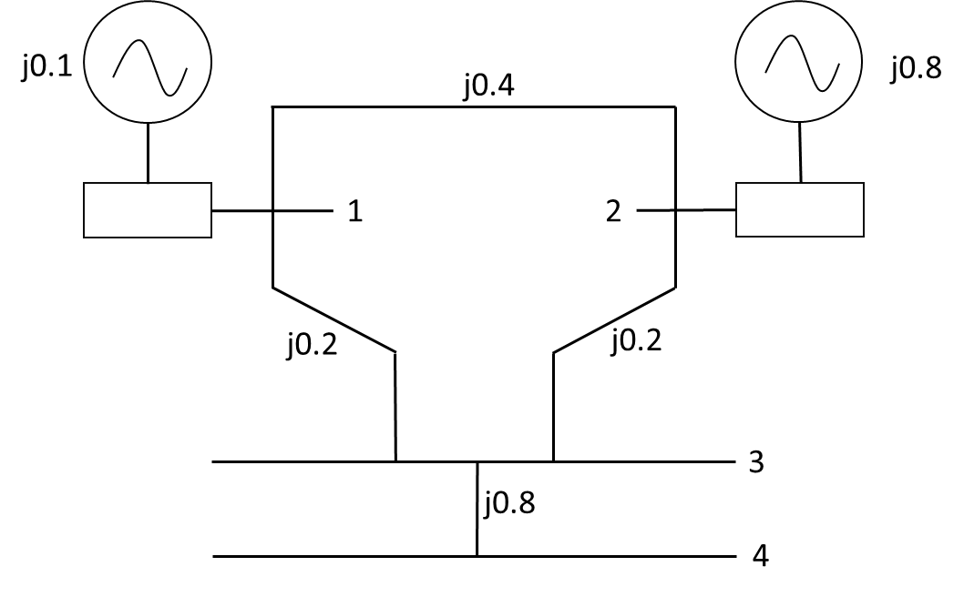

*Fig. 4.1: Diagram of Y- bus no.1*

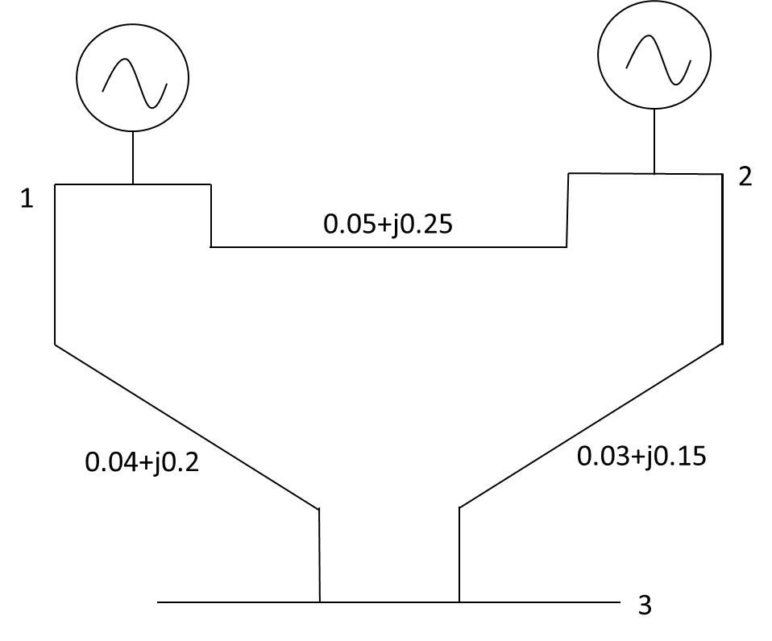

*Fig. 4.2: Diagram of Y- bus no.2*

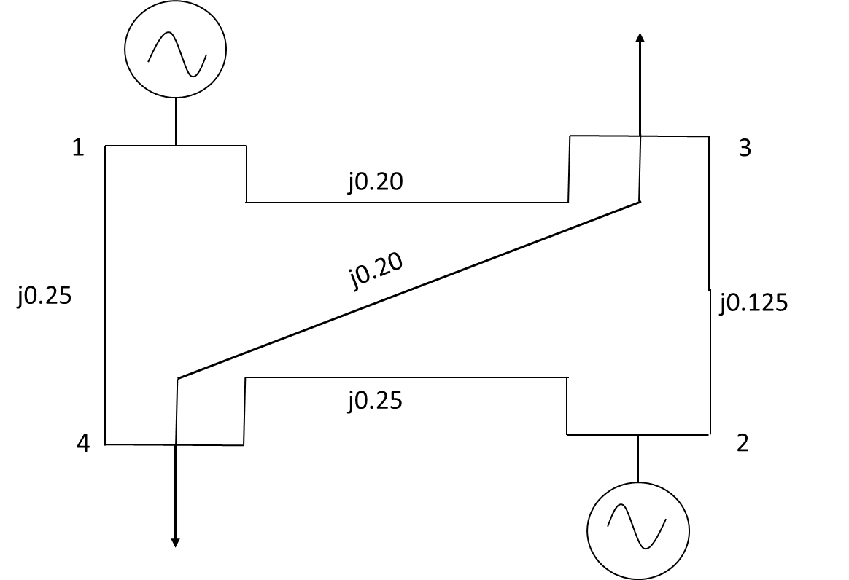

*Fig. 4.3: Diagram of Y- bus no.3*

* 1. **Algorithm**

1. Start
2. Read an excel file that has bus numbers ***i*** and ***j*** in the first two columns and resistance and admittance value in the third and fourth columns which represent impedance between the buses
3. Construct a matrix ***A*** whose element ***ai,j***denotes the impedance between ***i*** and ***j*** buses
4. Determine the length of matrix ***A***
5. Perform symmetric condition and construct a new matrix ***Z*** where 3rd and 4th column element of the excel file is equivalent to ***a+bj*** and it can be assigned to ***Zi,j***  later applying symmetric condition ***Zi,j*** = ***Zj,i***
6. Determine the length of new matrix ***Z***
7. Use looping condition for row j from 1 to length of Z and for column k from1 to length Z
8. If value of ***j*** row and ***k*** column is equal to zero, assign the element value as infinity
9. Determine inverse matrix of ***Z*** and assigned to ***Z***
10. Calculate the summation of ***Y*** matrix element row wise
11. Use looping condition for row ***u*** from 1 to length of ***Z*** and for column ***x*** from 1 to length ***Z***
12. Use formula if ***u≠x*** 𝑌***ux***= ***−𝑦ux*,** else 𝑌***ux*** =
13. Display ***Y*** as output
14. Determine the length of ***Y*** bus matrix
15. Provide the total no. of buses and load to be reduced as input
16. Use looping condition for ***h*** from 1 to length of load to be reduced and define new matrix, ***F*** inside the loop
17. Now use the formula inside a loop condition where for row ***t*** from 1 to (total no. Of buses-1) and for column ***r*** from 1 to (total no. of buses-1) to obtain the reduced bus matrix,
$$Y_{i,j}\left(new\right)= Y_{i,j}\left(old\right)- \frac{Y_{i,n}*Y_{n,j}}{Y_{n,n}}$$

18. End
    1. **Flow chart**

Read an excel file

Construct impedance matrix ***A***

Determining length of ***A*** matrix and n=length

Running loop for row ***w*** from 1 to ***n*** in symmetric condition

Z(A(w,1),A(w,2)) = A(w,3)+i*A(w,4);

Z(A(w,2),A(w,1)) = Z(A(w,1),A(w,2))

Determining length of ***Z*** matrix and m= length

Running loop for row ***j*** from 1 to ***m*** and column ***k*** from 1 to ***m***

If Z(j,k)==0

Assigning infinity to ***Z(j,k)***

Enter bus data in excel file

Display ***Y*** as output

Assigning inverse of ***Z(j,k)*** to ***y*** variable

If ***u=x***

Running loop for row ***u*** from 1 to ***m*** and column ***x*** from 1 to ***m***

Y(u,x)= sum of entries element wise and they are the value of diagonal elements

***Y(u,x)= -y(u,x)***

***Yes***

***No***

Start

Determining length of ***Y*** matrix and d=length

Input total no. of buses, ***f*** and load, ***g***

Running loop for row ***h*** from 1 to ***g*** in new matrix ***F***

Running loop for row ***t*** from 1 to ***d-1*** and Running loop for row r from 1 to ***d-1***

F(t,r) = Y(t,r)-((Y(t,d)*Y(d,r))/Y(d,d)

Y = F

d = d-1

End

* 1. **MATLAB Code & Output**
* **Generalized MATLAB Code for Y bus reduction for all the problems**

clc; %Clears previous data from command window

clear all; %Removes all variables from the current workspace

cd('F:\Study material\Lab\3-2\Power System I'); %change the file directory

A = xlsread('Exp02'); %Read the excel file

n = length(A); %Determine the length of the excel file

% Applying symmetric condition

for w=1:n

Z(A(w,1),A(w,2)) = A(w,3)+i*A(w,4);

Z(A(w,2),A(w,1)) = A(w,3)+i*A(w,4);

end

m = length(Z) %Determine the length of the new matrix

for j=1:m

for k=1:m

if Z(j,k) == 0

Z(j,k) = inf;

end

end

end

fprintf(' Z matrix is \n') %Display the text

disp(Z) %Display the output

y = 1./Z %Taking inverse impedance matrix

p = sum(y,2) %Taking symmetric summation

%Apply looping condition to determine value of the matrix element

for u=1:m

for x=1:m

if u~=x

Y(u,x)= -y(u,x); %For diagonal element

else

Y(u,x)= p(u); %For non-diagonal element

end

end

end

fprintf(' Y- bus matrix is \n') %Display the text

disp(Y) %Display the output

d = length(Y);

f = input('Total no. of buses: ');

g = input('No. of reduction: ');

for h=1:g %No. of reduction

F = zeros(d-1); %Define a new matrix

for t=1:(d-1) %Access all Y matrix element

for r=1:(d-1) %

F(t,r) = Y(t,r)-((Y(t,d)*Y(d,r))/Y(d,d));

end

end

Y = F;

d = d-1;

end

fprintf(' Z matrix is \n') %Display the text

disp(Y)

* **Output for Y- bus no. 1**

Z matrix is

0.0000 + 0.1000i 0.0000 + 0.4000i 0.0000 + 0.2000i Inf + 0.0000i

0.0000 + 0.4000i 0.0000 + 0.8000i 0.0000 + 0.2000i Inf + 0.0000i

0.0000 + 0.2000i 0.0000 + 0.2000i Inf + 0.0000i 0.0000 + 0.0800i

Inf + 0.0000i Inf + 0.0000i 0.0000 + 0.0800i Inf + 0.0000i

y =

0.0000 -10.0000i 0.0000 - 2.5000i 0.0000 - 5.0000i 0.0000 + 0.0000i

0.0000 - 2.5000i 0.0000 - 1.2500i 0.0000 - 5.0000i 0.0000 + 0.0000i

0.0000 - 5.0000i 0.0000 - 5.0000i 0.0000 + 0.0000i 0.0000 -12.5000i

0.0000 + 0.0000i 0.0000 + 0.0000i 0.0000 -12.5000i 0.0000 + 0.0000i

p =

0.0000 -17.5000i

0.0000 - 8.7500i

0.0000 -22.5000i

0.0000 -12.5000i

Y- bus matrix is

0.0000 -17.5000i 0.0000 + 2.5000i 0.0000 + 5.0000i 0.0000 + 0.0000i

0.0000 + 2.5000i 0.0000 - 8.7500i 0.0000 + 5.0000i 0.0000 + 0.0000i

0.0000 + 5.0000i 0.0000 + 5.0000i 0.0000 -22.5000i 0.0000 +12.5000i

0.0000 + 0.0000i 0.0000 + 0.0000i 0.0000 +12.5000i 0.0000 -12.5000i

Total no. of buses: 4

No. of reduction: 2

Reduced Y- bus matrix is

0.0000 -15.0000i 0.0000 + 5.0000i

0.0000 + 5.0000i 0.0000 - 6.2500i

* **Output for Y- bus no. 2**

Z matrix is

0.0000 + 1.0000i 0.0500 + 0.2500i 0.0400 + 0.0200i

0.0500 + 0.2500i 0.0000 + 1.0000i 0.0300 + 0.1500i

0.0400 + 0.0200i 0.0300 + 0.1500i Inf + 0.0000i

y =

0.0000 - 1.0000i 0.7692 - 3.8462i 20.0000 -10.0000i

0.7692 - 3.8462i 0.0000 - 1.0000i 1.2821 - 6.4103i

20.0000 -10.0000i 1.2821 - 6.4103i 0.0000 + 0.0000i

p =

20.7692 -14.8462i

2.0513 -11.2564i

21.2821 -16.4103i

Y- bus matrix is

20.7692 -14.8462i -0.7692 + 3.8462i -20.0000 +10.0000i

-0.7692 + 3.8462i 2.0513 -11.2564i -1.2821 + 6.4103i

-20.0000 +10.0000i -1.2821 + 6.4103i 21.2821 -16.4103i

Total no. of buses: 3

No. of reduction: 1

Reduced Y- bus matrix is

2.8402 - 9.8757i -2.8402 + 8.8757i

-2.8402 + 8.8757i 2.8402 - 9.8757i

* **Output for Y- bus no. 3**

Z matrix is

Inf + 0.0000i Inf + 0.0000i 0.0000 + 0.2000i 0.0000 + 0.2500i

Inf + 0.0000i Inf + 0.0000i 0.0000 + 0.1250i 0.0000 + 0.2500i

0.0000 + 0.2000i 0.0000 + 0.1250i Inf + 0.0000i 0.0000 + 0.2000i

0.0000 + 0.2500i 0.0000 + 0.2500i 0.0000 + 0.2000i Inf + 0.0000i

y =

0.0000 + 0.0000i 0.0000 + 0.0000i 0.0000 - 5.0000i 0.0000 - 4.0000i

0.0000 + 0.0000i 0.0000 + 0.0000i 0.0000 - 8.0000i 0.0000 - 4.0000i

0.0000 - 5.0000i 0.0000 - 8.0000i 0.0000 + 0.0000i 0.0000 - 5.0000i

0.0000 - 4.0000i 0.0000 - 4.0000i 0.0000 - 5.0000i 0.0000 + 0.0000i

p =

0.0000 - 9.0000i

0.0000 -12.0000i

0.0000 -18.0000i

0.0000 -13.0000i

Y- bus matrix is

0.0000 - 9.0000i 0.0000 + 0.0000i 0.0000 + 5.0000i 0.0000 + 4.0000i

0.0000 + 0.0000i 0.0000 -12.0000i 0.0000 + 8.0000i 0.0000 + 4.0000i

0.0000 + 5.0000i 0.0000 + 8.0000i 0.0000 -18.0000i 0.0000 + 5.0000i

0.0000 + 4.0000i 0.0000 + 4.0000i 0.0000 + 5.0000i 0.0000 -13.0000i

Total no. of buses: 4

No. of reduction: 2

Reduced Y- bus matrix is

0.0000 - 5.1100i 0.0000 + 5.1100i

0.0000 + 5.1100i 0.0000 - 5.1100i

* 1. **Discussion & Conclusion**

In this experiment, we designed an algorithm, flow chart, and programmed a generalized code for three different Y- bus system. In each case, we extracted the values from an excel file and formulated necessary condition to assign values to variables. Through this generalized coding format, we easily design and calculate reduced Y bus matrix for any given power system.

The only adjustment to the code we may need is changing the directory of the file to work with and the given data saved inside the file. The bus numbers and the resistance and reactance values must also be given in the order defined for the code to work and give accurate result.